Welcome!
Date
Name
Spouse
Address
City
State Zip _________
Email

Please Contact By
❑ Card  Phone  Visit

Telephone Best Time to Call
Home ______________
Work ______________

Guest: First Time Second Time
Are you a church member: yes no
Church
City, State

Circle Appropriate Age/Grade Group(s)
Preschool: Ages: B-1 2-3 4-5
Children: Grades: K 1 2 3 4 5 6
Youth: Grades: 7 8 9 10 11 12
Adults: Ages:18-29 30s 40s 50s 60s+

How did you learn about our church?
Newspaper Friend Yellow Pages Mail
Other

I am a guest of:

New in the Community? Yes No
Names & ages of children at home

Weekly Service & Activity Schedule

April 8, 2018
9:30 a.m. New Commandment Kids
9:45 a.m. Sunday School
11:00 a.m. Worship Service
6:00 p.m. Evening Service/Business Mtg

Week of April 8, 2018
Wednesday 6:30 pm……………..……….Meal/Bible Study
Friday 6:30 pm……………….…………..Men’s 42 Night

April
19………………………………Make & Take Card Class
May
6……………………………….New Commandment Kids
6………………….Assoc. Music Festival – Chappel Hill
13……………………………………………..Mother’s Day


April Stuffed Animals
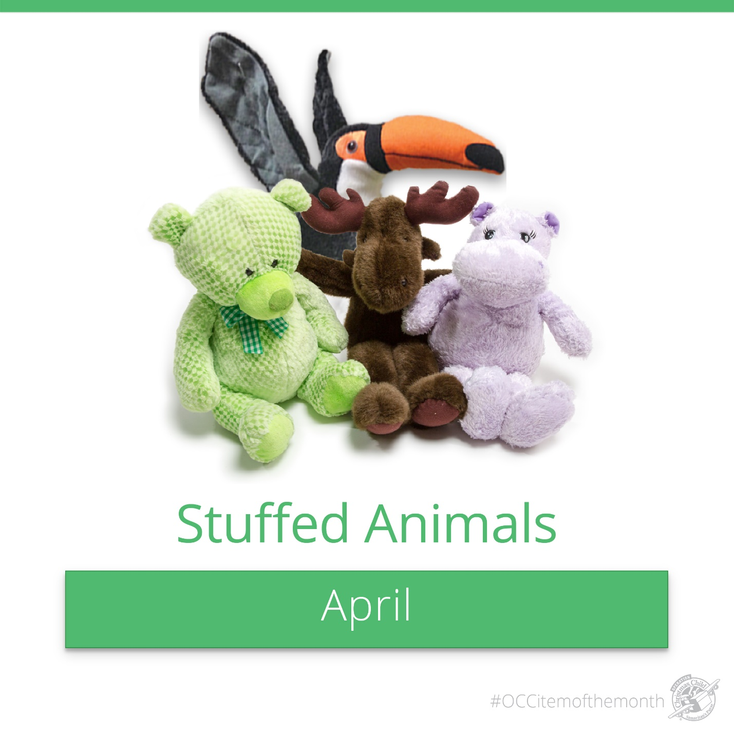
Remember, the animals have to be small enough to fit in a shoebox with other items. There is a box in the foyer for the items and a shoebox for monetary donations

Make & Take Card Class with
Mother’s Day Themes
Contact Brenda Williams if you are interested in attending

Sunday Apr.8 during the worship service



Knobbs Springs Baptist Church

April 8, 2018

Church Information:

KnobbsSpringsBC.com KnobbsSpringsBaptist@gmail.com

1662 CR 305, McDade, Texas 78650 512-273-2743

David Atwood, Pastor Cell 512-470-5098

Patti Radford, Office Manager Cell 512-968-7821

